|  |  |
| --- | --- |
| A picture of a winding road and trees | **Submitted By**  Amna Tahir  **Submitted To**  Prof. Sidra Batool  **Roll Number**  BSITF18E014    **CS&IT** |

**Hardware Generation**

Generation in computer terminology is a change in technology a computer is/was being used. Initially, the generation term was used to distinguish between varying hardware technologies. Nowadays, generation includes both hardware and software, which together make up an entire computer system.

There are five computer generations known till date. Each generation has been discussed in detail along with their time period and characteristics. Following are the main five generations of computers.

|  |  |  |
| --- | --- | --- |
| **S No.** | **Generation** | **Description** |
| **1** | First Generation | The period of first generation: 1946-1959. Vacuum tube based. |
| **2** | Second Generation | The period of second generation: 1959-1965. Transistor based. |
| **3** | Third Generation | The period of third generation: 1965-1971. Integrated Circuit based. |
| **4** | Fourth Generation | The period of fourth generation: 1971-1980. VLSI microprocessor based. |
| **5** | Fifth Generation | The period of fifth generation: 1980-onwards. ULSI microprocessor based. |

**First Generation**

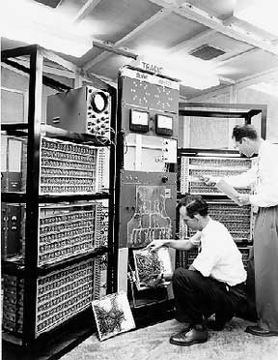The period of first generation was from 1946-1959. The computers of first generation used vacuum tubes as the basic components for memory and circuitry for CPU (Central Processing Unit). These tubes, like electric bulbs, produced a lot of heat and the installations used to fuse frequently. Therefore, they were very expensive and only large organizations were able to afford it.

In this generation, mainly batch processing operating system was used. Punch cards, paper tape, and magnetic tape was used as input and output devices. The computers in this generation used machine code as the programming language.

The main features of the first generation are

* Vacuum tube technology
* Unreliable
* Supported machine language only
* Very costly
* Generated a lot of heat
* Slow input and output devices
* Huge size
* Need of AC
* Non-portable
* Consumed a lot of electricity

Some computers of this generation were

* ENIAC
* EDVAC
* UNIVAC
* IBM-701
* IBM-650

Advantages of First Generation of Computer

* Vacuum tubes were used as electronic component.
* Electronic digital computers were developed for the first time.
* These computers were the fastest calculating devices of their time.
* Computations were performed in millisecond.

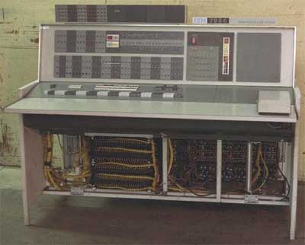**Second Generation**

The period of second generation was from 1959-1965. In this generation, transistors were used that were cheaper, consumed less power, more compact in size, more reliable and faster than the first generation machines made of vacuum tubes. In this generation, magnetic cores were used as the primary memory and magnetic tape and magnetic disks as secondary storage devices.

In this generation, assembly language and high-level programming languages like FORTRAN, COBOL were used. The computers used batch processing and multiprogramming operating system.

The main features of second generation are

* Use of transistors
* Reliable in comparison to first generation computers
* Smaller size as compared to first generation computers
* Generated less heat as compared to first generation computers
* Consumed less electricity as compared to first generation computers
* Faster than first generation computers
* Still very costly
* AC required
* Supported machine and assembly languages

Some computers of this generation were

* IBM 1620
* IBM 7094
* CDC 1604
* CDC 3600
* UNIVAC 1108

Advantages of Second Generation of Computer

* Smaller in size as compares to 1st generation.
* Much more reliable.
* Less heat generated.
* Computation was performing in micro second.
* Less hardware and maintenance problem.
* Could be used for commercial use

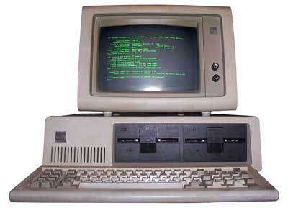**Third Generation**

The period of third generation was from 1965-1971. The computers of third generation used Integrated Circuits (ICs) in place of transistors. A single IC has many transistors, resistors, and capacitors along with the associated circuitry.

The IC was invented by Jack Kilby. This development made computers smaller in size, reliable, and efficient. In this generation remote processing, time-sharing, multiprogramming operating system were used. High-level languages (FORTRAN-II TO IV, COBOL, PASCAL PL/1, BASIC, ALGOL-68 etc.) were used during this generation.

The main features of third generation are

* IC used
* More reliable in comparison to previous two generations
* Smaller size
* Generated less heat
* Faster
* Lesser maintenance
* Costly
* AC required
* Consumed lesser electricity
* Supported high-level language

Some computers of this generation were

* IBM-360 series
* Honeywell-6000 series
* PDP (Personal Data Processor)
* IBM-37

Advantages of Third Generation of Computer

* Smaller in size as compared to second generation.
* More reliable.
* Portable
* Less electricity consumption.
* Heat generation was rare.
* General purpose computer.

**Fourth Generation**

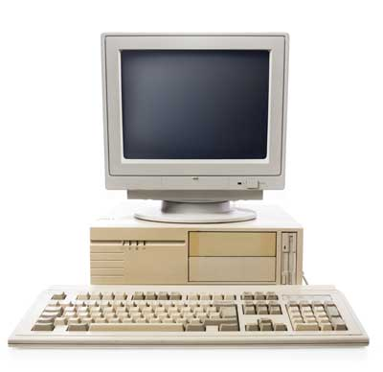The microprocessor has resulted in the fourth generation computers being smaller and cheaper than their predecessors. The fourth generation computers are also portable and more reliable. They generate much lesser heat and require less maintenance compared to their predecessors. GUI and pointing devices facilitate easy use and learning on the computer. Networking has resulted in resource sharing and communication among different computers.

4G is a very different technology as compared to 3G and was made possible practically only because of the advancements in the technology in the last 10 years. Its purpose is to provide high speed , high quality and high capacity to users while improving security and lower the cost of voice and data services, multimedia and internet over IP. Potential and current applications include amended mobile web access, IP telephony , gaming services, high-definition mobile TV, video conferencing, 3D television, and cloud computing.

The key technologies that have made this possible are MIMO (Multiple Input Multiple Output) and OFDM (Orthogonal Frequency Division Multiplexing). The two important 4G standards are WiMAX (has now fizzled out) and LTE (has seen widespread deployment). LTE (Long Term Evolution) is a series of upgrades to existing UMTS technology and will be rolled out on Telstra's existing 1800MHz frequency band. The max speed of a 4G network when the device is moving is 100 Mbps or 1 Gbps for low mobility communication like when stationary or walking, latency reduced from around 300ms to less than 100ms, and significantly lower congestion. When 4G first became available, it was simply a little faster than 3G. 4G is not the same as 4G LTE which is very close to meeting the criteria of the standards. To download a new game or stream a TV show in HD, you can do it without buffering .

Advantages of Fourth Generation of Computer

* Smaller in size and much reliable.
* No cooling system required in many cases.
* Much faster computation.
* Portable and cheap.
* The heat generated was negligible.
* Totally general purpose computer.
* Cheapest among all generations
* All types of High level languages can be used in this type of computers
* Totally general purpose

**Fifth Generation**

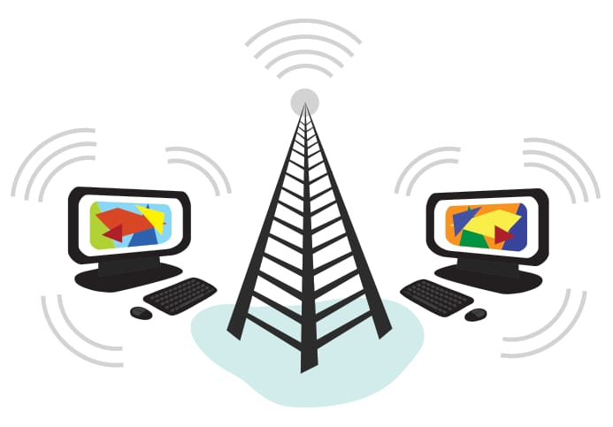The goal of fifth generation computing is to develop computers that are capable of learning and self-organization. The fifth generation computers use Super Large Scale Integrated (SLSI) chips that are able to store millions of components on a single chip. These computers have large memory requirements. The fifth generation computers are based on Artificial Intelligence (AI). They try to simulate the human way of thinking and reasoning. Artificial Intelligence includes areas like Expert System (ES), Natural Language Processing (NLP), speech recognition, voice recognition, robotics, etc.

This generation of computers uses parallel processing that allows several instructions to be executed in parallel, instead of serial execution. Parallel processing results in faster processing speed. The Intel dual-.core microprocessor uses parallel processing.

Advantages of Fifth Generation of Computer

* Very large storage capacity.
* Long bit processor builds.
* Artificial Intelligence Language developed.
* Advancement in Parallel Processing.
* Advancement in Superconductor technology.
* These computers are much smaller in size than other generation computers

**Internet Introduction**

The Internet is an increasingly important part of everyday life for people around the world. But if you've never used the Internet before, all of this new information might feel a bit confusing at first.

Throughout this tutorial, we'll try to answer some basic questions you may have about the Internet and how it's used. When you're done, you'll have a good understanding of how the Internet works, how to connect to the Internet, and how to browse the Web.

The Internet is a global network of billions of computers and other electronic devices. With the Internet, it's possible to access almost any information, communicate with anyone else in the world, and do much more.

You can do all of this by connecting a computer to the Internet, which is also called going online. When someone says a computer is online, it's just another way of saying it's connected to the Internet.

**Generations**

**1G - First Generation**

This was the first generation of cell phone technology . The very first generation of commercial cellular network was introduced in the late 70's with fully implemented standards being established throughout the 80's. It was introduced in 1987 by Telecom (known today as Telstra), Australia received its first cellular mobile phone network utilising a 1G analog system. 1G is an analog technology and the phones generally had poor battery life and voice quality was large without much security, and would sometimes experience dropped calls . These are the analog telecommunications standards that were introduced in the 1980s and continued until being replaced by 2G digital telecommunications. The maximum speed of 1G is 2.4 Kbps .

**2G - Second Generation**

Cell phones received their first major upgrade when they went from 1G to 2G. The main difference between the two mobile telephone systems (1G and 2G), is that the radio signals used by 1G network are analog, while 2G networks are digital . Main motive of this generation was to provide secure and reliable communication channel. It implemented the concept of CDMA and GSM . Provided small data service like sms and mms. Second generation 2G cellular telecom networks were commercially launched on the GSM standard in Finland by Radiolinja (now part of Elisa Oyj) in 1991. 2G capabilities are achieved by allowing multiple users on a single channel via multiplexing. During 2G Cellular phones are used for data also along with voice. The advance in technology from 1G to 2G introduced many of the fundamental services that we still use today, such as SMS, internal roaming , conference calls, call hold and billing based on services e.g. charges based on long distance calls and real time billing. The max speed of 2G with General Packet Radio Service ( GPRS ) is 50 Kbps or 1 Mbps with Enhanced Data Rates for GSM Evolution ( EDGE ). Before making the major leap from 2G to 3G wireless networks, the lesser-known 2.5G and 2.75G was an interim standard that bridged the gap.

**3G - Third Generation**

This generation set the standards for most of the wireless technology we have come to know and love. Web browsing, email, video downloading, picture sharing and other Smartphone technology were introduced in the third generation. Introduced commercially in 2001, the goals set out for third generation mobile communication were to facilitate greater voice and data capacity, support a wider range of applications, and increase data transmission at a lower cost .

The 3G standard utilises a new technology called UMTS as its core network architecture - Universal Mobile Telecommunications System. This network combines aspects of the 2G network with some new technology and protocols to deliver a significantly faster data rate. Based on a set of standards used for mobile devices and mobile telecommunications use services and networks that comply with the International Mobile Telecommunications-2000 ( IMT-2000 ) specifications by the International Telecommunication Union. One of requirements set by IMT-2000 was that speed should be at least 200Kbps to call it as 3G service.

3G has Multimedia services support along with streaming are more popular. In 3G, Universal access and portability across different device types are made possible (Telephones, PDA's, etc.). 3G increased the efficiency of frequency spectrum by improving how audio is compressed during a call, so more simultaneous calls can happen in the same frequency range. The UN's International Telecommunications Union IMT-2000 standard requires stationary speeds of 2Mbps and mobile speeds of 384kbps for a "true" 3G. The theoretical max speed for HSPA+ is 21.6 Mbps.

Like 2G, 3G evolved into 3.5G and 3.75G as more features were introduced in order to bring about 4G. A 3G phone cannot communicate through a 4G network , but newer generations of phones are practically always designed to be backward compatible, so a 4G phone can communicate through a 3G or even 2G network .

**4G - Fourth Generation**

4G is a very different technology as compared to 3G and was made possible practically only because of the advancements in the technology in the last 10 years. Its purpose is to provide high speed , high quality and high capacity to users while improving security and lower the cost of voice and data services, multimedia and internet over IP. Potential and current applications include amended mobile web access, IP telephony , gaming services, high-definition mobile TV, video conferencing, 3D television, and cloud computing.

The key technologies that have made this possible are MIMO (Multiple Input Multiple Output) and OFDM (Orthogonal Frequency Division Multiplexing). The two important 4G standards are WiMAX (has now fizzled out) and LTE (has seen widespread deployment). LTE (Long Term Evolution) is a series of upgrades to existing UMTS technology and will be rolled out on Telstra's existing 1800MHz frequency band. The max speed of a 4G network when the device is moving is 100 Mbps or 1 Gbps for low mobility communication like when stationary or walking, latency reduced from around 300ms to less than 100ms, and significantly lower congestion. When 4G first became available, it was simply a little faster than 3G. 4G is not the same as 4G LTE which is very close to meeting the criteria of the standards. To download a new game or stream a TV show in HD, you can do it without buffering .

Newer generations of phones are usually designed to be backward-compatible , so a 4G phone can communicate through a 3G or even 2G network. All carriers seem to agree that OFDM is one of the chief indicators that a service can be legitimately marketed as being 4G. OFDM is a type of digital modulation in which a signal is split into several narrowband channels at different frequencies. There are a significant amount of infrastructure changes needed to be implemented by service providers in order to supply because voice calls in GSM , UMTS and CDMA2000 are circuit switched, so with the adoption of LTE, carriers will have to re-engineer their voice call network. And again, we have the fractional parts: 4.5G and 4.9G marking the transition of LTE (in the stage called LTE-Advanced Pro) getting us more MIMO, more D2D on the way to IMT-2020 and the requirements of 5G .

**5G - Fifth Generation**

5G is a generation currently under development , that's intended to improve on 4G. 5G promises significantly faster data rates, higher connection density, much lower latency, among other improvements. Some of the plans for 5G include device-to-device communication, better battery consumption, and improved overall wireless coverage. The max speed of 5G is aimed at being as fast as 35.46 Gbps , which is over 35 times faster than 4G.

Key technologies to look out for: Massive MIMO , Millimeter Wave Mobile Communications etc. Massive MIMO, milimetre wave, small cells, Li-Fi all the new technologies from the previous decade could be used to give 10Gb/s to a user, with an unseen low latency, and allow connections for at least 100 billion devices . Different estimations have been made for the date of commercial introduction of 5G networks. Next Generation Mobile Networks Alliance feel that 5G should be rolled out by 2020 to meet business and consumer demands.